Reading a Scientific Article
Attempting to read a scientific or scholarly research article for the first time may seem overwhelming and confusing. This guide details how to read a scientific article step-by-step. First, you should not approach a scientific article like a textbook— reading from beginning to end of the chapter or book without pause for reflection or criticism. Additionally, it is highly recommended that you highlight and take notes as you move through the article. Taking notes will keep you focused on the task at hand and help you work towards comprehension of the entire article.
- Skim the article. This should only take you a few minutes. You are not trying to comprehend the entire article at this point, but just get a basic overview. You don’t have to read in order; the discussion/conclusions will help you to determine if the article is relevant to your research. You might then continue on to the Introduction. Pay attention to the structure of the article, headings, and figures.
- Grasp the vocabulary. Begin to go through the article and highlight words and phrases you do not understand. Some words or phrases you may be able to get an understanding from the context in which it is used, but for others you may need the assistance of a medical or scientific dictionary. Subject-specific dictionaries available through our Library databases and online are listed below.
- Identify the structure of the article and work on your comprehension. Most journals use an IMRD structure: An abstract followed by Introduction, Methods, Results, and Discussion. These sections typically contain conventional features, which you will start to recognize. If you learn to look for these features you will begin to read and comprehend the article more quickly.
  - The abstract gives a quick overview of the article. It will usually contain four pieces of information: purpose or rationale of study (why they did it); methodology (how they did it); results (what they found); conclusion (what it means). Begin by reading the abstract to make sure this is what you are looking for and that it will be worth your time and effort.
  - The introduction gives background information about the topic and sets out specific questions to be addressed by the authors. You can skim through the introduction if you are already familiar with the paper’s topic.
  - The methods section gives technical details of how the experiments were carried out and serves as a “how-to” manual if you wanted to replicate the same experiments as the authors. This is another section you may want to only skim unless you wish to identify the methods used by the researchers or if you intend to replicate the research yourself.
  - The results are the meat of the scientific article and contain all of the data from the experiments. You should spend time looking at all the graphs, pictures, and tables as these figures will contain most of the data.
  - Lastly, the discussion is the authors’ opportunity to give their opinions. Keep in mind that the discussions are the authors’ interpretations and not necessarily facts. It is still a good place for you to get ideas about what kind of research questions are still unanswered in the field and what types of questions you might want your own research project to tackle. (See the Future Research Section of the Research Process for more information).
- Read the bibliography/references section. Reading the references or works cited may lead you to other useful resources. You might also get a better understanding of the basic terminology, main concepts, major researchers, and basic terminology in the area you are researching.
- Reflect on what you have read and draw your own conclusions. As you are reading jot down any questions that come to mind. They may be answered later on in the article or you may have stumbled upon something that the authors did not consider. Here are some examples of questions you may ask yourself as you read:
  - Have I taken time to understand all the terminology?
  - Am I spending too much time on the less important parts of this article?
  - Do I have any reason to question the credibility of this research?
  - What specific problem does the research address and why is it important?
  - How do these results relate to my research interests or to other works which I have read?
- Read the article a second time in chronological order. Reading the article a second time will reinforce your overall understanding. You may even start to make connections to other articles that you have read on this topic.

Subject-Specific Dictionaries
- Business
- Education
- Health Sciences
- Marriage & Family Science
- Psychology
- Research Methods
- Social Work
- Technology
- 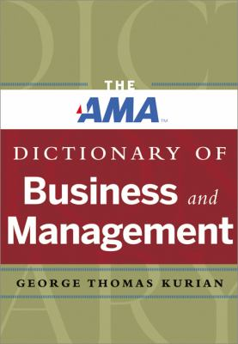The AMA Dictionary of Business and Management by George Thomas Kurin
ISBN: 9780814420287
Publication Date: 2013
Covers a vast range of terminology from all areas of business including management, strategy, finance, human resources, economics, marketing, sales, insurance, and international business.
- 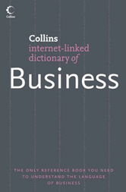Collins Dictionary of Business by Christopher Pass (Editor)
ISBN: 9781849721691
Publication Date: 2006
Covers all the main areas of business theory and practice: marketing, production, finance, personnel, business policy and international business.
- 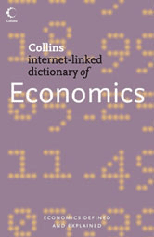Collins Dictionary of Economics by C. L. Pass (Editor); Leslie Davies (Editor); Bryan Lowes (Editor)
ISBN: 9781849721769
Publication Date: 2007
Summarizes the theoretical principles behind the science of economics and their application in such areas as competition policy, agricultural policy, fiscal policy and monetary policy.
- 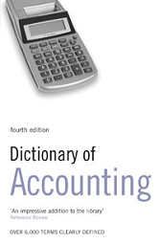Dictionary of Accounting by S. M.H. Collin
ISBN: 9781849722469
Publication Date: 2008
Provides a basic vocabulary of terms used in accounting, from personal finance and investments to company accounts, balance sheets and stock valuations.
- Dictionary of Business by A&C Black
ISBN: 9781408198476
Publication Date: 2006
Contains basic business terms that cover all aspects of business life from the office to the stock exchange and international trade fairs.
- 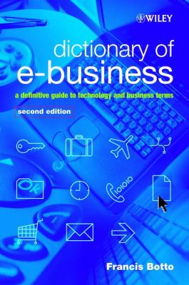Dictionary of E-Business by Francis Botto
ISBN: 9780470844700
Publication Date: 2003
Includes extended coverage of wireless and mobile terms, demonstrates clear applications to both technical and business markets, and covers all the latest developments in this fast moving field.
- 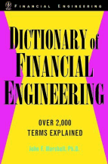Dictionary of Financial Engineering by John F. Marshall
ISBN: 9781849721424
Publication Date: 2006
A practical guide to the inside language of the world of derivative instruments and risk management.
- 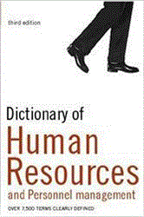Dictionary of Human Resources and Personnel Management by A. Ivanovic (Editor); P.H. Collin (Editor)
ISBN: 9781849721967
Publication Date: 2007
Key terms, covering all aspects of human resources, including recruitment and selection, appraisals, payment systems, dismissals and industrial relations
- 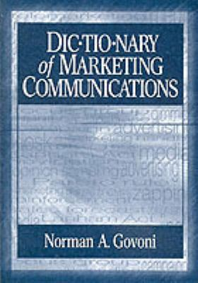Dictionary of Marketing Communications by Norman A. Govoni
ISBN: 9780761927716
Publication Date: 2003
Contains more than 4,000 entries, including key terms and concepts in the promotion aspect of marketing with coverage of advertising, sales promotion, public relations, direct marketing, personal selling and e-marketing.
- Dictionary of Strategy: Strategic Management A-Z by Louise Kelly; Chris Booth
ISBN: 9780761930730
Publication Date: 2004
Presents over 550 important strategic management terms and concepts.
- 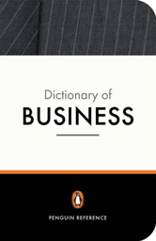New Penguin Business Dictionary by Graham Bannock (Editor)
ISBN: 9781849722353
Publication Date: 2007
Covers all aspects of business from accounting through marketing and organizational behavior to human resource management.
- 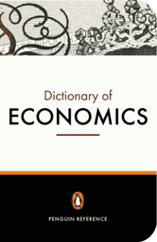Penguin Dictionary of Economics by Graham Bannock; R. E. Baxter; Evan Davis
ISBN: 9781849722377
Publication Date: 2007
Explains a host of economic terms, from acceleration principle to venture capital, Euro to X-efficiency, globalization to zero-sum game.
- 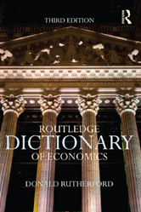Routledge Dictionary of Economics by Donald Rutherford
ISBN: 9780415122917
Publication Date: 2013
Provides clear, definitive explanations of the key terms, issues, theories and concepts in economics today.
- 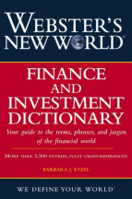Webster's New World Finance and Investment Dictionary by Barbara Etzel
ISBN: 9781849721486
Publication Date: 2006
Clear, accessible, and cross-referenced explanations of today's most essential financial terms, including vocabulary related to accounting, finance, banks and banking, economics, investing, markets, real estate, and securities.

